**COMPUTER SCIENCE DEPARTMENT**

Computer organization and Assembly language

**Lab Task # 03**

**Last date of Submission: 11th March 2024**

# Submitted To: Sir Ahmed Saleem Khattak

**Student Name: Jehanzeb Khalid**

# Reg. Number: 2212391

# 

**Code # 01**

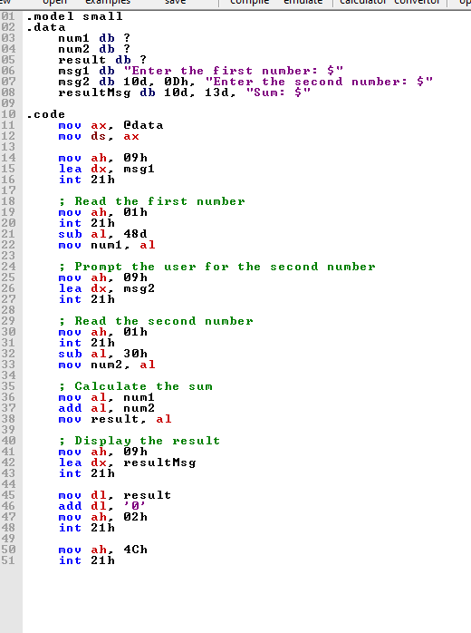

**Output**

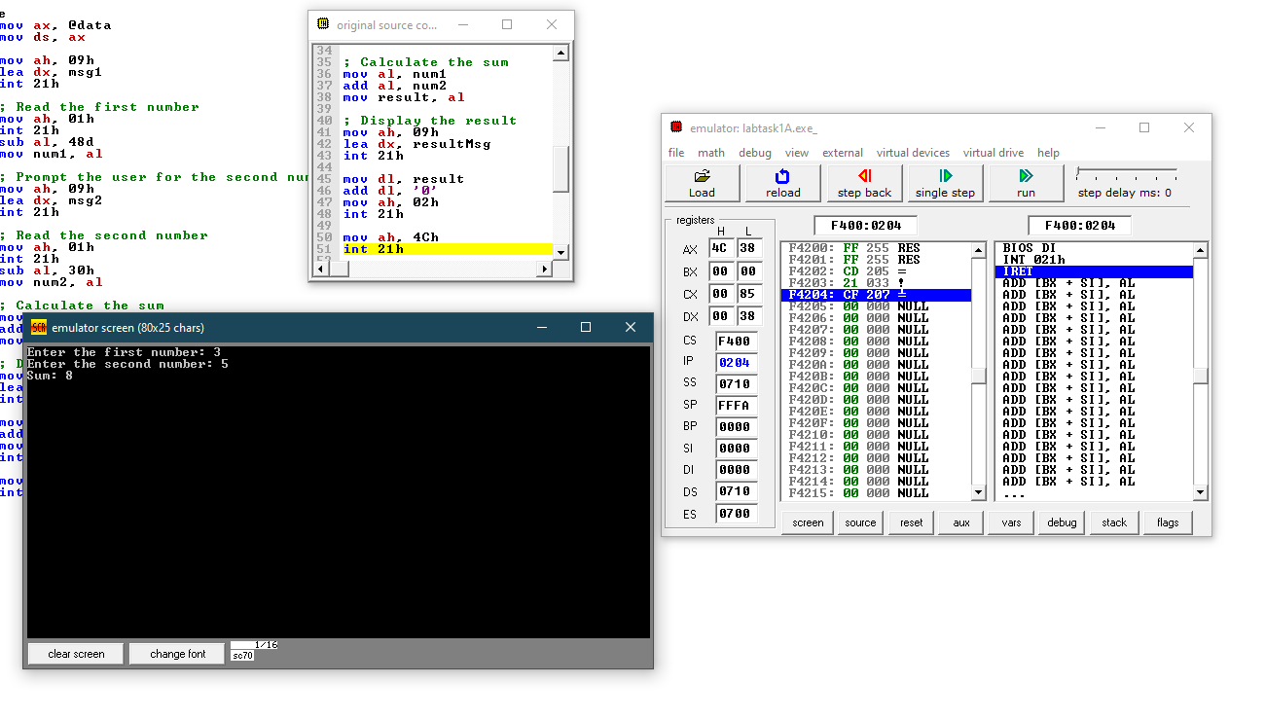

**Code #02**

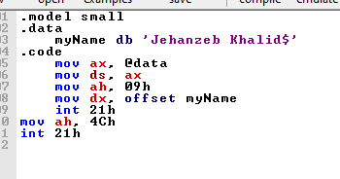

**Output**

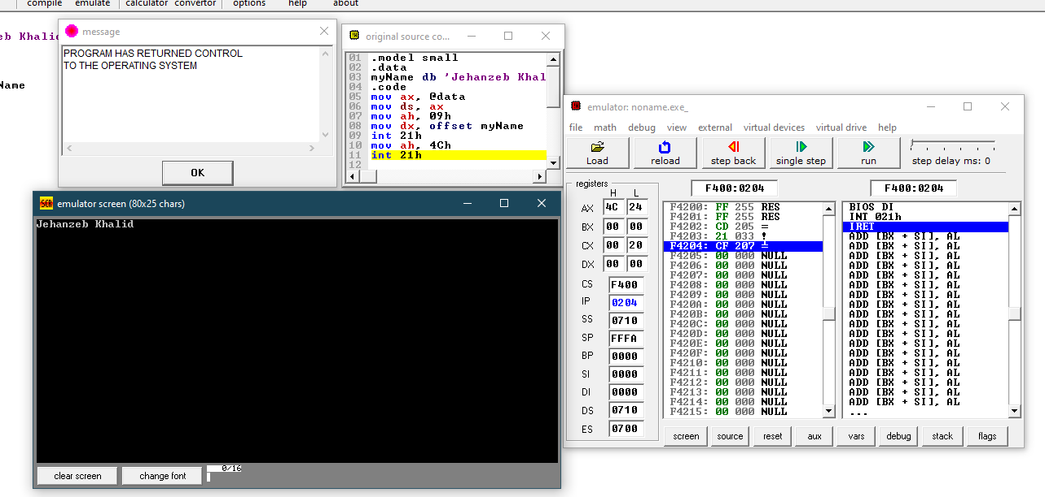

**Code #03**

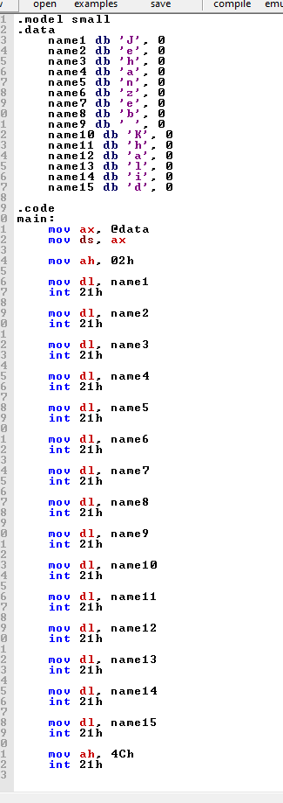

**OUTPUT**

